Print Nightmare
TTP
- Initial access
T1078 – Valid Accounts
Domain user to reach RPC from print spooler service
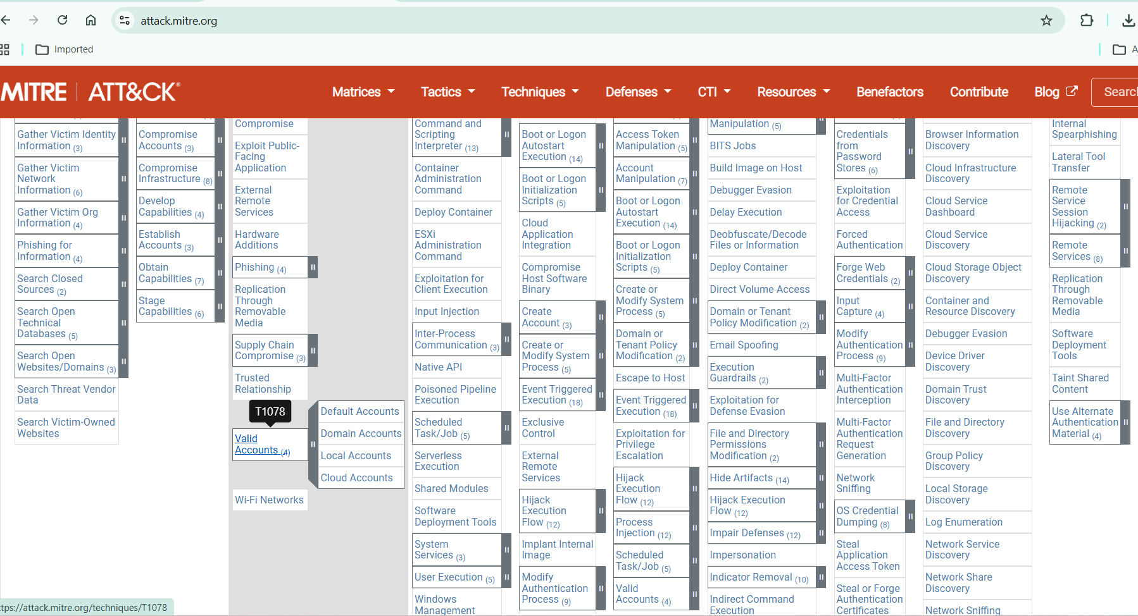
- Execution
T1059 – Command and Scripting Interpreter
Uploading DLL by PowerShell
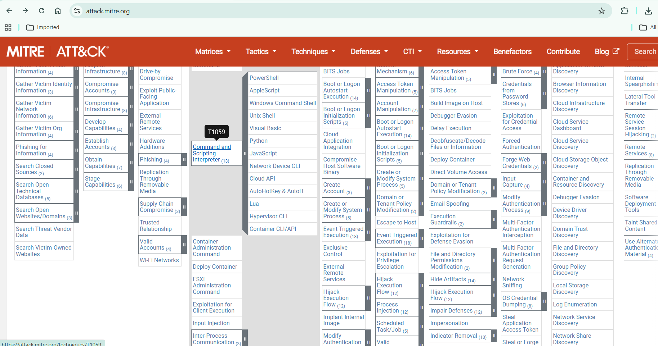
T1106 – Native API
Using windows API
RpcAddPrinterDriverEx
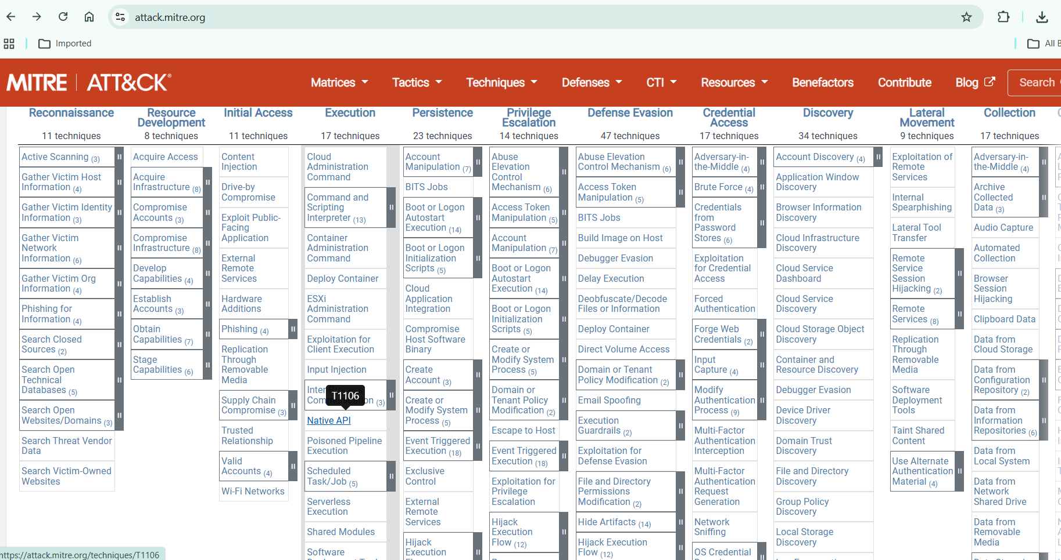
- Privilege escalation
T1068 – Exploitation for Privilege Escalation
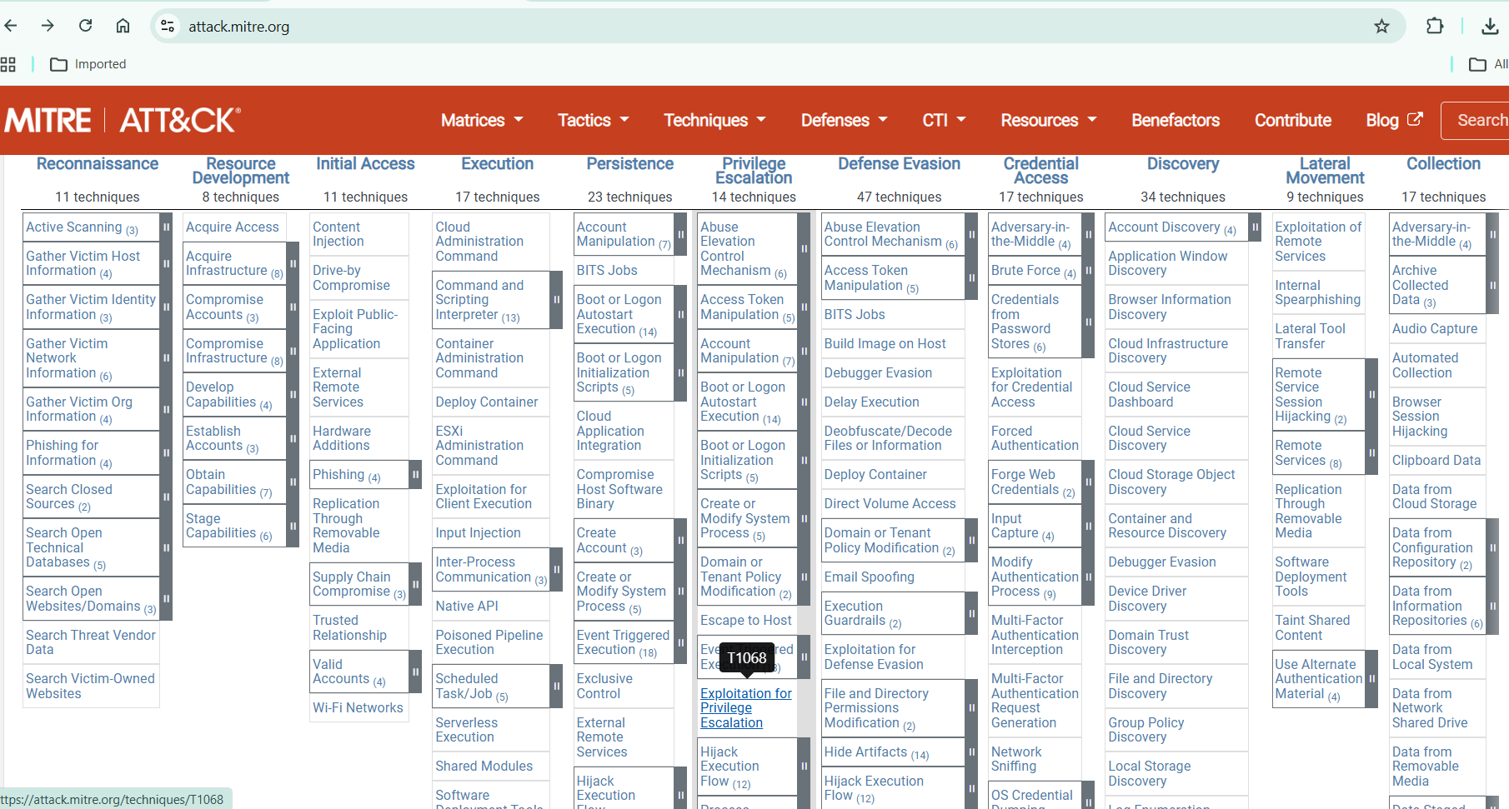
- Persistence
T1547 – Boot or Logon AutoStart Execution
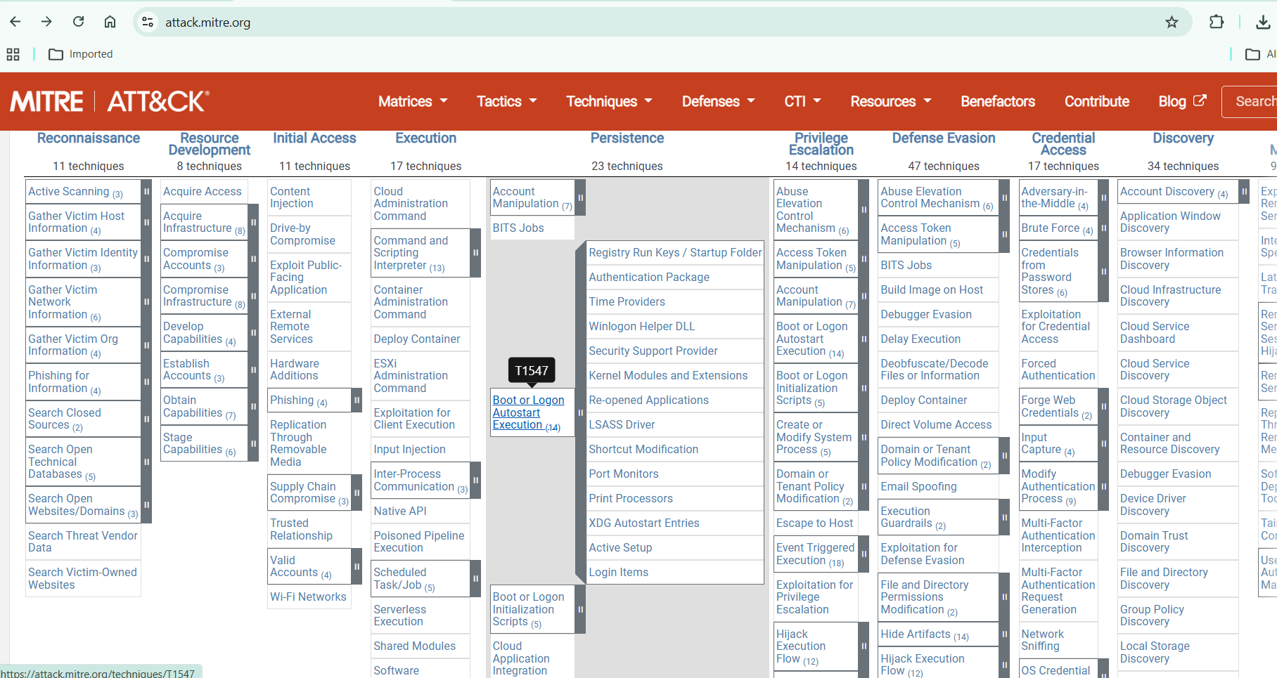
T1543.003 – Create or Modify System Process (Windows Service)
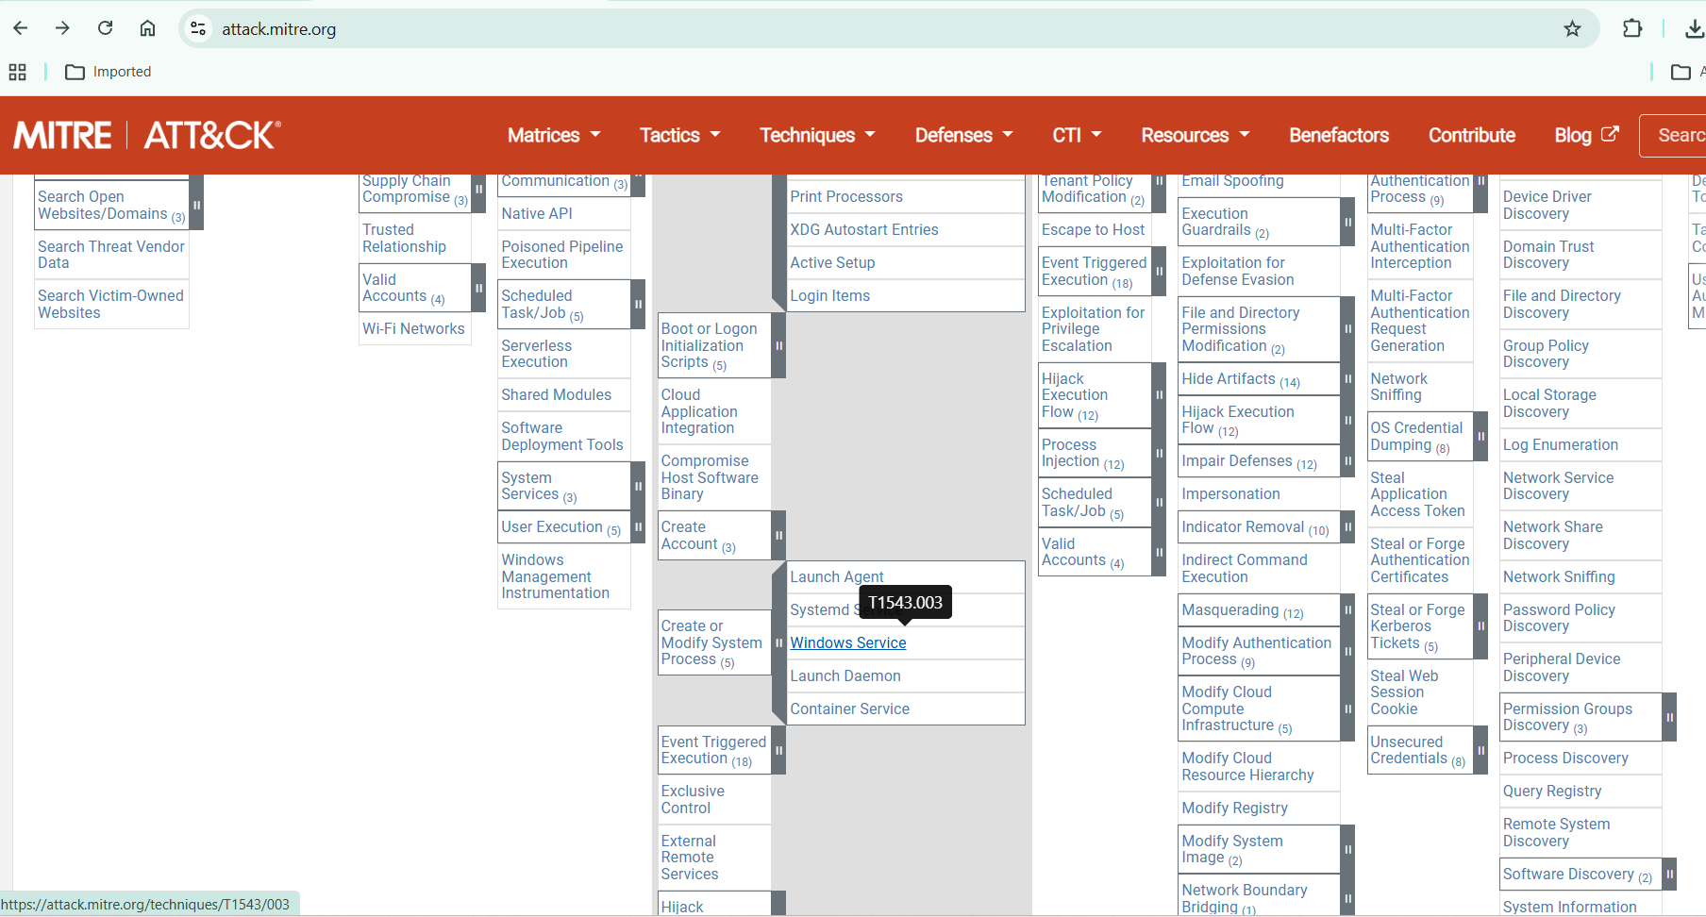
- Defense evasion
T1218 – Signed Binary Proxy Execution
spoolsv.exe
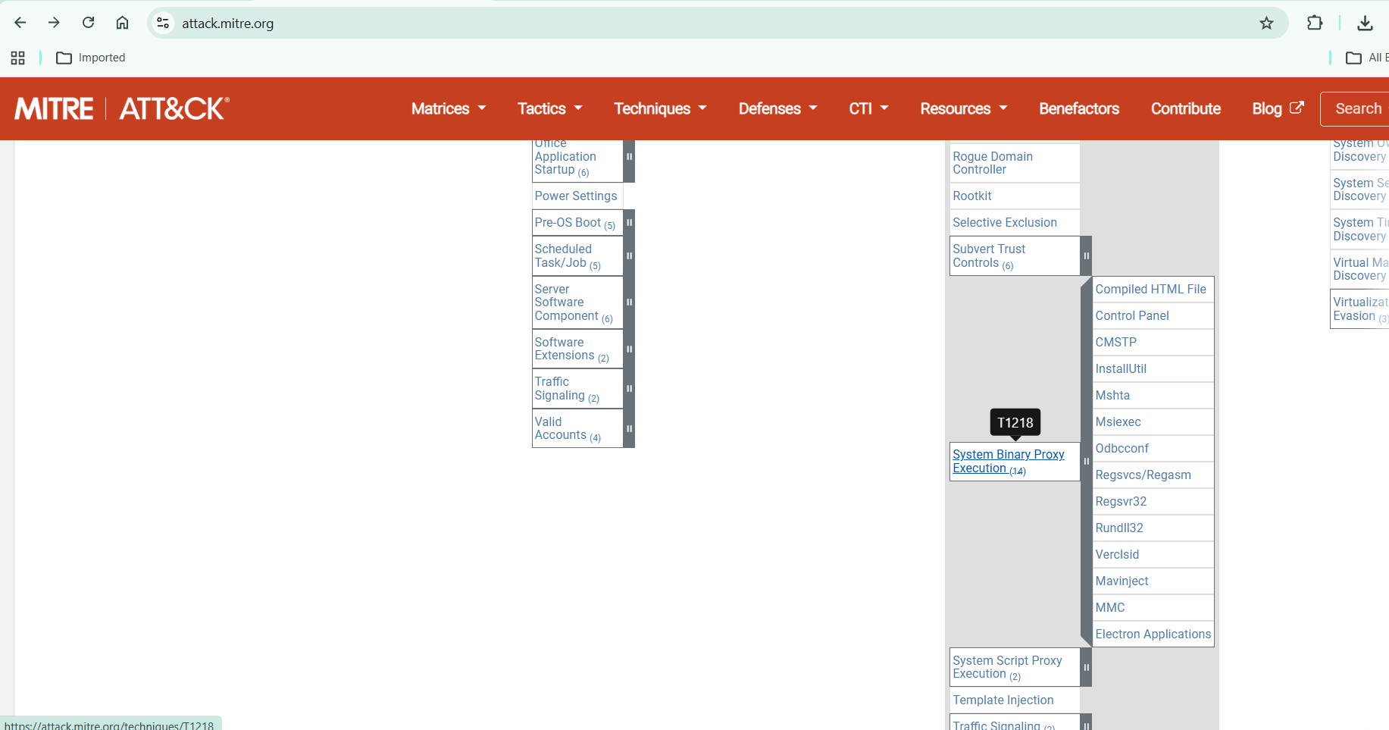
T1036 – Masquerading
DLL as printer name
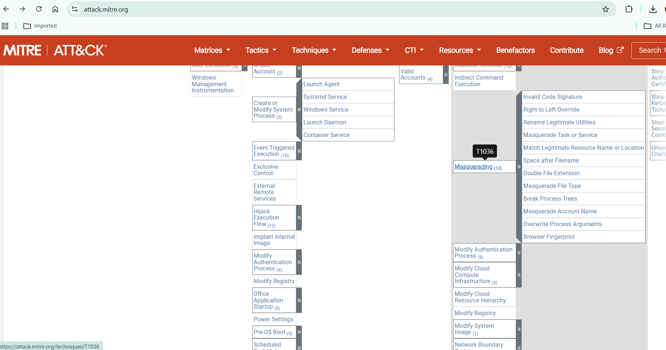
- Lateral movment
T1021 – Remote Services
Reach more devices by RPC/SMB
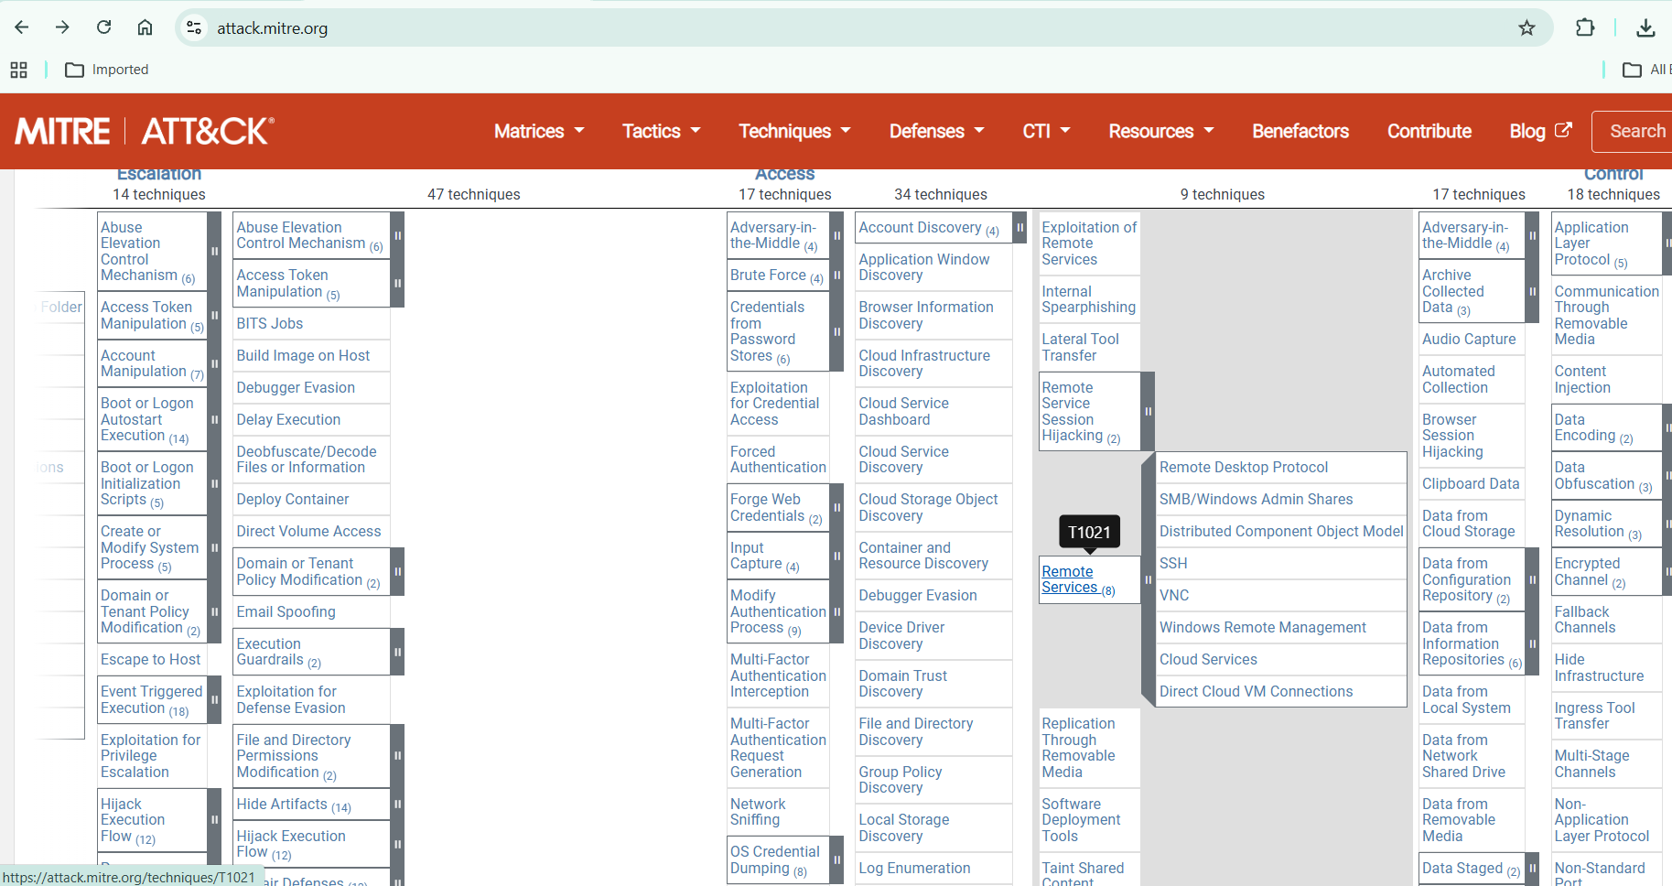
T1570 – Lateral Tool Transfer
Uploading DLL by SMB
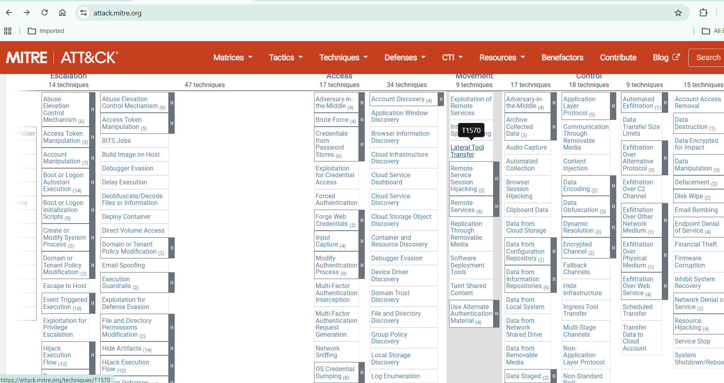
- Impact
T1484 – Domain Policy Modification
Control domain controller

PrintNightmare refers to multiple vulnerabilities in the Windows Print Spooler service, most notably:
- CVE-2021-34527 – Remote Code Execution
- CVE-2021-1675 – Privilege Escalation
The flaw allows an attacker to load a malicious DLL via the Print Spooler service, leading to SYSTEM-level compromise.
Key Differences:
- CVE-2021-1675 (Initial Vulnerability): Originally identified as a Local Privilege Escalation (LPE) vulnerability, it allows an attacker with low-level access to the system to escalate privileges to SYSTEM level. It was patched in June 2021.
- CVE-2021-34527 (The "True" PrintNightmare): This is a critical Remote Code Execution (RCE) vulnerability that allows remote, unauthenticated attackers to execute arbitrary code with SYSTEM privileges. It was discovered after the initial patch for CVE-2021-1675 was released and found to be insufficient to prevent remote exploitation.
- Network IOC Summary
Indicator Type | What to Look For
SMB Traffic | TCP 445 to suspicious internal host
Print Spooler | Unexpected remote driver install
File Creation | DLL in spool\drivers directory
Outbound Traffic | C2 beaconing after spooler crash
Process | spoolsv.exe spawning cmd.exe or powershell

Indicators of Compromise (IOC)

Windows Event Logs

Event ID 316 (PrintService Operational)

Event ID 808 / 812
Driver installation attempts

Event ID 4624
Logon Type 3 (Network logon)

